## 

**Pseudo noise generator (PNG)** **2**

**Modulator** **5**

2 Symbols 6

20 Symbols 7

Spectrum 8

**Demodulator** **9**

Mixer 9

**Matches Filter = Integrator** **12**

**BER Measurement** **12**

**Measure the bit error ratio BER** **14**

Diagram 14

Table 14

**Evaluation** **1**4

## 

## 

## Pseudo noise generator (PNG)

Setup: Clock frequency: 4kHz.

Due to the TTL level output of the PNG, the output voltage level never reaches 0V.

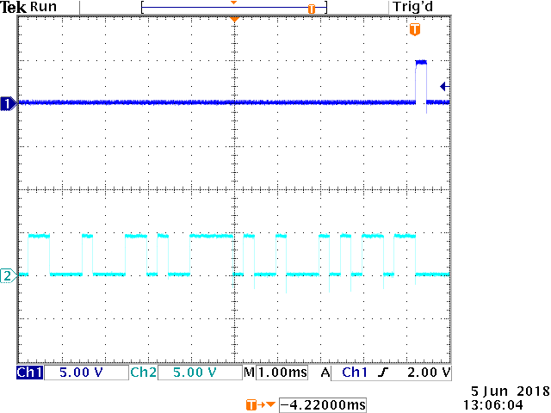

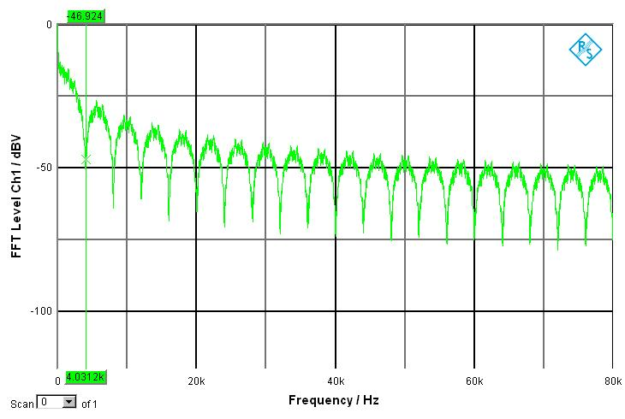

### DC Component Graph

A cursor was used on the oscilloscope to measure the DC Offset. The value being 224mV.

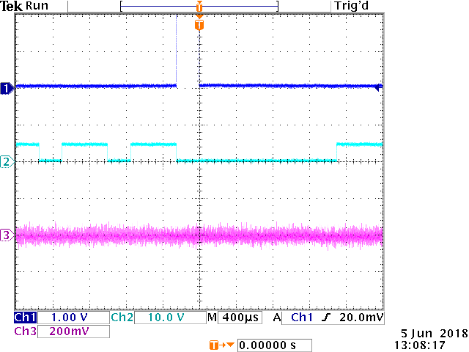

## 

## 

## Modulator

### 

### 

### 

### 

### 

### 

### 

### 

### 

### 2 Symbols

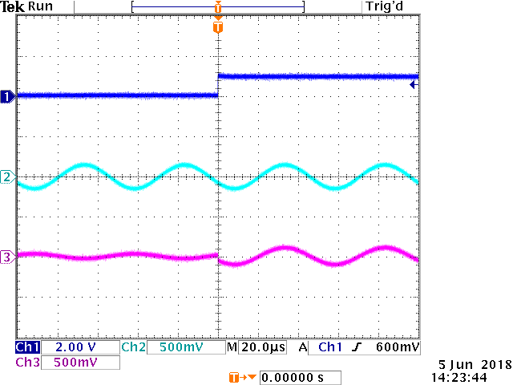

### 20 Symbols

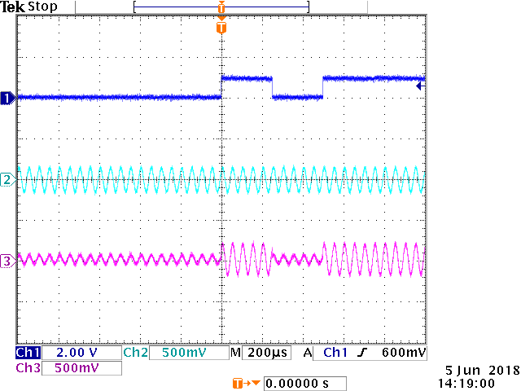

### Spectrum

Range 0-40kHz



## 

## 

## 

## 

## Demodulator

### Mixer

Adjust to OOK modulation using “Mod_In_Offset

### Spectrum

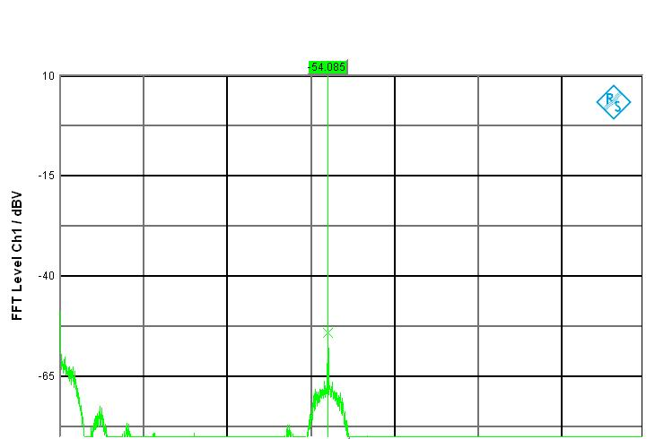

### 2 Symbols

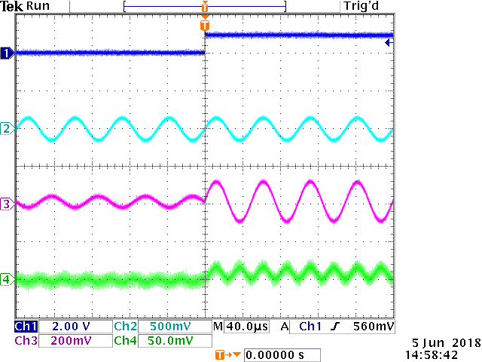

### 20 Symbols

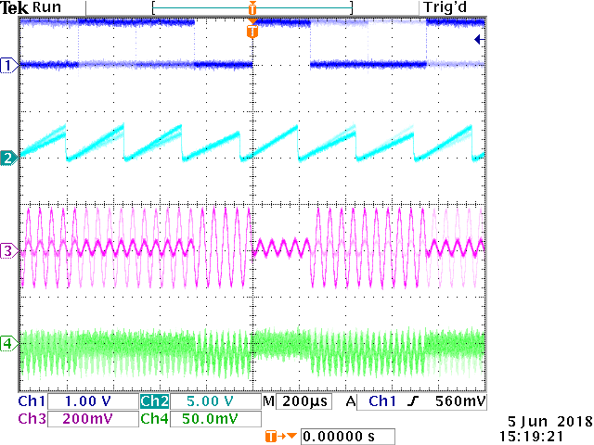

## Matches Filter = Integrator

### Graph

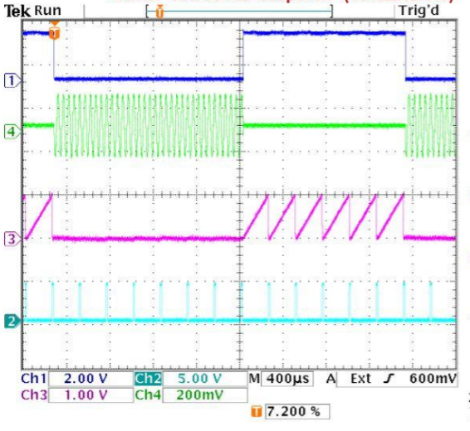

## 

## 

## 

## 

## BER Measurement

The optimal decision threshold level is in the middle of the HIGH (1) and the LOW (0).

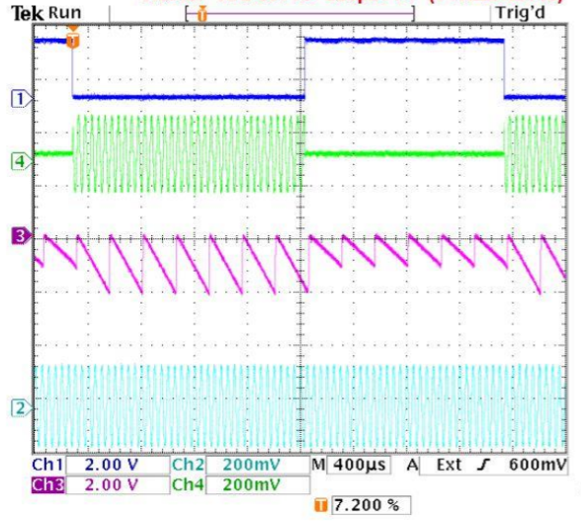

## Measure the bit error ratio BER

### Diagram

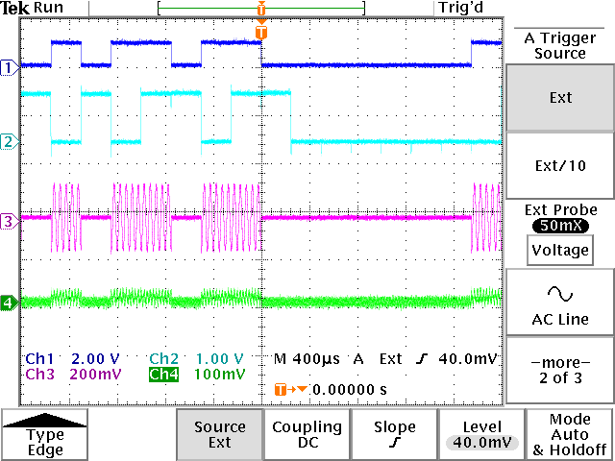

### Table

|  |  |
| --- | --- |
| Noise in dB | Bit Error Ratio |
| -100 | 0 |
| -60 | 0 |
| -40 | 0 |
| -30 | 0.018 |
| -20 | 0.107 |
| -10 | 0.2 |
| 0 | 0.253 |

## Evaluation

Without noise being present in the system the bit error ratio remains 0. Adding noise to our system increases the value of the BER progressively. At -100 dB BER has the value 0, while at 0 dB we have 0.253 as the value of BER.